**Coders for Causes- Webpage Brief**

**Proposed web address:** www.home2health.com

**Key objectives/purpose:**

* provide a platform to support a network of professionals/individuals interested in homelessness and health
* Build evidence for what works
* Promote timely research that works (why research matters)
* Promote information/idea sharing
* Safe space to ask questions

**What the webpage is not:**

* It is not a clearing house

**Key stakeholders**

|  |  |
| --- | --- |
| Primary stakeholders: | Secondary stakeholders: |
| * Individuals working in the health or homelessness sector (NGOs, policy makers, etc..) |  |

**Timeframe:** xxx

**Colour scheme:**

Polished Pine Wintergreen Dream Purple Navy Opera Mauve Blue Sapphire

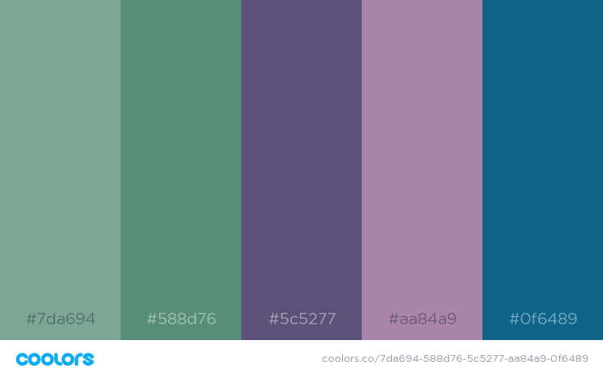

**Fonts:** (example only based on what we use for reports)

|  |  |  |
| --- | --- | --- |
| Headings | Content | Quotes ? |
| Flama Semicondensed Book  Flama Semicondensed Medium  Flama Semicondensed Bold | Source Sans Pro  Source Sans Pro Semibold  Source Sans Pro Black | *Apud Roman (Italic)*  *Apud Medium (Italic)*  *Apud Black (Italic)* |

This is the website we created for Lisa a number of years ago – its pretty rough.. but may be useful to gather some background on our work <http://lisajwood.com/>



|  |  |  |  |  |
| --- | --- | --- | --- | --- |
| **Landing** | **Tabs** | **Sub-Tabs** | **Content** | **Downloadable content** |
| Home | About Home2Health |  | There has been a growing number of homeless health programs and research in Australia recently.  This is a space to share ideas and learn what else is happening in homelessness and health in Australia. | n/a |
| Our Partners |  | Our research partners: (example below)    Our Network: (Interactive Map of collaborators.. example): | Not downloadable but a page of logos ? need to check re permissions to upload..   * UWA * Coders for Causes ? * Homeless Healthcare * RPH |
| Contact Us |  | Home2Health is a research team from the School of Population and Global Health at the University of Western Australia. Please contact us below:  Create online form (example) |  |
| What is happening in Australia? | Housing First Programs  I assume I will also need to create a blurb for this general tab level ? | 50 Lives 50 Homes | The 50 Lives 50 Homes project is the first Housing First program in Western Australia, and one of the first in Australia.  50 Lives is a collective impact initiative aiming to provide long-term housing and support to the most vulnerable individuals and families rough sleeping in Perth. The collaborative includes 28 different organisations in Perth (with backbone support from Ruah Community Services), including homelessness services, housing agencies, health providers, and mental health and community services.  To date, over 200 people have been housed through the 50 Lives project.  The Home2Health Team have been involved in the evaluation of 50 Lives since 2016. The evaluation draws on a mix of data including the VI-SPDAT, administrative hospital and police data and interviews with 50 Lives clients and organisations involved in the project. See below for more information | This is an example from Homeless Hub… wonder if we can have our downloadable content in a similar format (i.e. a button style with report/infographic name at bottom of page) <https://www.homelesshub.ca/about-homelessness/homelessness-101/who-homeless>    Facebook: <https://www.facebook.com/50Lives50HomesPerth/>  50 Lives 50 Homes Report 1 (June 2017)  50 Lives 50 Homes Infographic (June 2017)  50 Lives 50 Homes Snapshot Report (Apr 2018)  50 Lives 50 Homes Report 2 (Sept 2018)  Hospital Collaboration Paper (Wood et al 2018) |
| 20 Lives 20 Homes | The 20 Lives 20 Homes project will be the first place-based trial of the 50 Homes 50 Lives housing first model in the metropolitan area, based in Fremantle. The St Patrick’s 20 Lives 20 Homes team will work along with Ruah and a range of collaborating agencies, to provide intensive wrap around support to individuals facing complex barriers to exiting homelessness.  This project is due to commence in 2019. | n/a |
| Hospital Programs | Royal Perth Hospital | Royal Perth Hospital is a major public teaching hospital located in the Perth CBD. In mid-2016, Homeless Healthcare established its first in-reach program in collaboration with Royal Perth Hospital. The in reach program is modelled on the internationally renowned and evidence based Pathway program that operates in 11 hospitals in the UK.  The aim of RPH Homeless Team is to improve outcomes for homeless patients by providing support, improved discharge planning and continuity of care. GPs and nurses from Homeless Healthcare work alongside RPH Homeless Team staff.  The Home2Health Team have been actively involved in the Team's evaluation since its establishment and have assisted in the advocacy and expansion on their role including a recent Department of Health RTP grant to pilot a dual diagnosis service <link to HODDS tab>.  More information on the evaluation below: | WA Excellence Awards Finalist: <https://rph.health.wa.gov.au/About-us/News/RPHs-Homeless-Team-is-a-WA-Health-Excellence-Awards-finalist>  RPH Homeless Team Report 1 (May 2018)  RPH Homeless Team Infographic 1 (May 2018)  RPH Homeless Team Report 2 (Feb 2019)  RPH Homeless Team Summary of Report 2 (Feb 2019)  Hospital Collaboration Paper (Wood et al 2018)  Tackling Health Disparities Paper (Stafford and Wood 2017)  Winter Flu Reduction Strategy Report 1 (TBA) |
| St Vincent's Hospital Melbourne | Shannen to send through at some point… | SVHM Homelessness Programs Report (Sep 2017)  SVHM Homelessness Programs Infographic  SVHM Homelessness Programs ALERT Infographic  SVHM Homelessness Programs The Cottage Infographic  SVHM Homelessness Programs CHOPS Infographic  SVHM Homelessness Programs Prague House Infographic  The Cottage: Providing medical respire care (Gazey et al 2018) |
| St Vincent's Hospital Sydney | TBA | TBA |
| Katherine Hospital | The Katherine Individual Support Program (KISP) is a collaborative case management approach in Katherine to address the needs of people who struggle to achieve quality of life outcomes due to the impact of chronic ill health, addiction, social and emotional, and homelessness.  The Home2Health research team will be commencing an evaluation of this program xxxx. | TBA |
| GP Services | Homeless Healthcare | Homeless Healthcare is a primary health service for people experiencing, or at risk of, homelessness. It offers a variety of services to help people experiencing homelessness in Perth including:   * **Street health**: Nurses providing care in public places within the Perth CBD and Fremantle to target rough sleepers’ medical needs * **Mobile GP**: Clinics are provided at homeless drop-in centres throughout the Perth CBD * **After-hours support services (AHSS)**: 24-hour support program provided to 50 Lives 50 Homes clients * **RPH in-reach**: Supports patients and connects them with community services. * **Dual diagnosis service (HODDS)**   The Home2Health research team has been conducting an ongoing evaluation of these services since 2016. | Homeless Healthcare: <https://homelesshealthcare.org.au/>  Hospital Collaboration Paper (Wood et al 2018)  Homeless health care- meeting the challenges of providing primary care (Davies and Wood 2018)  Homeless Healthcare Clinical Senate (Nov 2016)  Homeless Healthcare Evaluation Report 1 (Oct 2018)  Homeless Healthcare Summary of Report 1 (Oct 2018)  Street Health Infographic (Mar 2019) |
| Dual Diagnosis Services | Homeless Outreach Dual Diagnosis Service (HODDS) | Shannen to send through at some point… | TBA |
| Claredon Homeless Outreach Psychiatric Service (CHOPS) | CHOPS is a specialist homelessness outreach service of SVHM’s Mental Health service. It is specifically designed to work with people with mental illness who are homeless or in tenuous housing. The CHOPS team has a  strong multidisciplinary focus and is made up of nurses, occupational therapists, and social workers, with a total caseload of 40 clients at any given time. The team provides assertive and flexible outreach including opportunistic “check-ins” with clients if they are seen on the street, and extends to locating clients who have temporarily moved out of the CHOPS catchment area. | CHOPS Infographic |
| Peer Worker Programs | Choices | Shannen to send through at some point… | Choices Report 1 (Oct 2018) |
| Outreach | Street Health | Street Health is a service operated by Homeless Healthcare that provides healthcare to rough sleepers in CBD parks in Perth and Fremantle. | Street Health Infographic (Mar 2019)  Street Health Appeal: <https://thewest.com.au/news/perth/medics-for-homeless-in-funding-plea-ng-b88525248z> |
| Street Doctor | TBA | TBA |
| Medical Recovery Centre | The Cottage | The Cottage is a supportive, home like environment where Complex Care Services and Hospital in the Home (HITH) services are provided to people who are homeless or at risk of homelessness. The aim is to provide holistic, recuperative care to clients with a nursing need, as an alternative to staying in hospital.  The Cottage focuses on building rapport and trust between clients and staff, enabling staff to establish a safe environment and platform from which they can address clients’ health issues. | The Cottage Infographic  The Cottage: Providing medical respire care (Gazey et al 2018) |
| Tierney House | TBA | TBA |
| TBA Perth | The recent Sustainable Health Review recommended the establishment of MRC in Perth xxx  Something re joint effort of HHC, St Barts etc.. |  |
| Members Area | About Membership |  | The principal intention behind this website is to create a space to facilitate communication between all those working with the health needs of people who are homeless.  For full use of the site, and active membership of this community of practice, is open to xxxxx.  If you would wish to join, go to the 'become a member' tab. Xxxx, |  |
| Become a member |  | Form similar to this: <http://pielink.net/register/> |  |
| Discussion Board |  |  |  |
| Blog |  |  | Monthly blogs from members  Link to sign up to blog mailing list  Potential extra tab for achieve ? |  |
| In the news |  |  | Set up some sort of google alert filter (i.e. any news to do with homelessness and health in Aus??) |  |

Example of tabs:

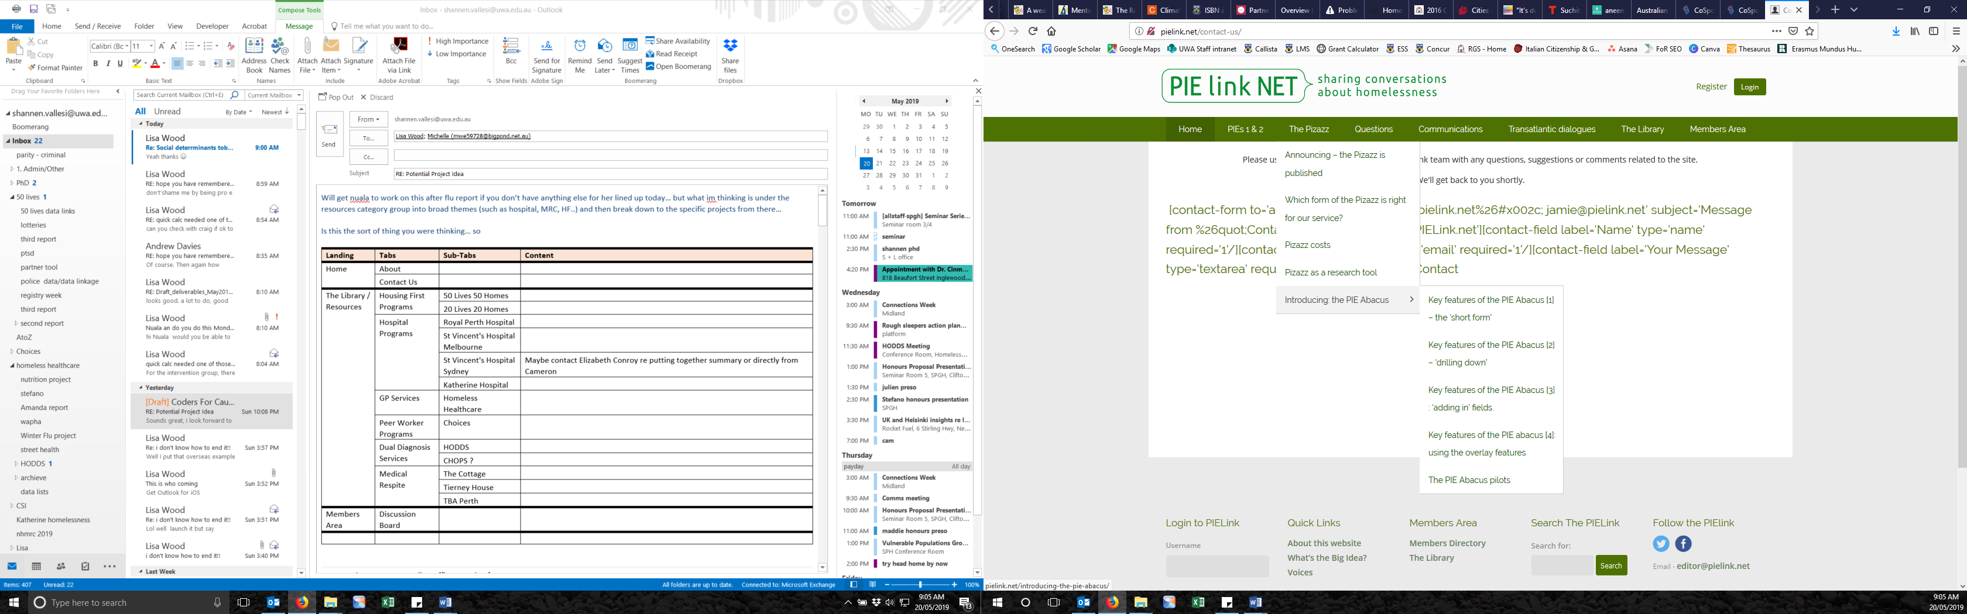

**20 Lives 20 Homes**

**50 Lives 50 Homes**

**Housing First Programs**

**Whats Happening…**